

**NAME: HAMID GHULAM HAMZA.**

**REG.No. 51230.**

**COURSE: DBMS LAB**

**LAB_5:**

Consider the following schema:

1. **Customer** (cust_id, cust_name).
2. **Product** (prod_code ,prod_name, unit_price)
3. **Customer_Order** (order_code, order_date, cust_id)
4. **Order_Item** (order_code, prod_code, num_of_units)
5. Develop DDL of in SQL
6. Add Column contact in Customer Table
7. Add Column company_name in Product Table

**ANSWER:**

CREATE DATABASE supermarket

CREATE TABLE customer(

customer_id INT NOT NULL,

customer_name VARCHAR(50)

);

ALTER TABLE customer

ADD PRIMARY KEY(customer_id)

CREATE TABLE Product(

Prod_code INT NOT NULL,

prod_name VARCHAR(50),

unit_price INT

);

ALTER TABLE Product

ADD PRIMARY KEY(Prod_code)

CREATE TABLE Customer_Order(

order_code INT NOT NULL,

order_date VARCHAR(50)

);

ALTER TABLE Customer_Order

ADD PRIMARY KEY(order_code)

CREATE TABLE Order_Item(

order_code INT NOT NULL,

prod_code INT NOT NULL,

num_of_unit INT

PRIMARY KEY(order_code)

);

ALTER TABLE customer

ADD COLUMN contact INT

ALTER TABLE product

ADD COLUMN company_name VARCHAR(50)

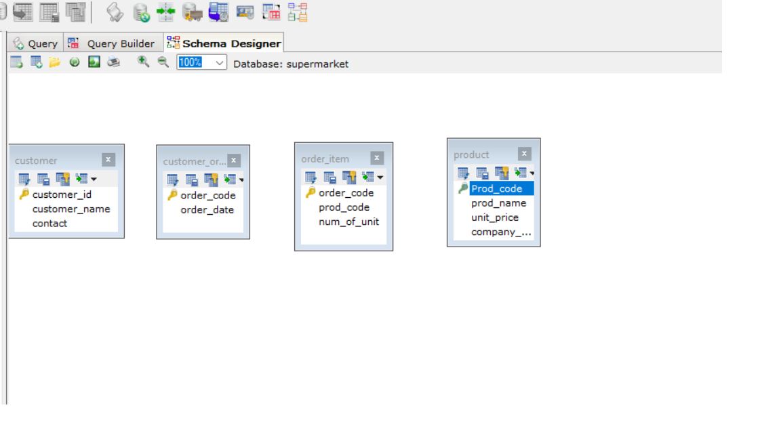

**LAB_6:**

Insert the following data into the following table

**Movie** (id, title, year, director)

|  |  |  |  |
| --- | --- | --- | --- |
| **Id** | **Title** | **Year** | **Director** |
| 1 | Ben hur | 2016 | Thomas |
| 2 | Get Smart | 2012 | Richard Bell |
| 3 | Spider Man | 2009 | Tam Morry |
| 4 | Batman V/S Super Man | 2015 | Gerald Hond |

**ANSWER:**

CREATE DATABASE movie

CREATE TABLE movie(

i_d INT NOT NULL PRIMARY KEY,

title VARCHAR(50),

Movie_year INT,

Director VARCHAR(50)

);

INSERT INTO movie(i_d, title, Movie_year, Director)

VALUES (1,'Ben hur', 2016, 'Thomas'),

(2,'Get Smart', 2012, 'Richard Bell'),

(3,'Spider Man', 2009, 'Tam Morry'),

(4,'Batman V/S Super Man', 2015, 'Gerald Hond');

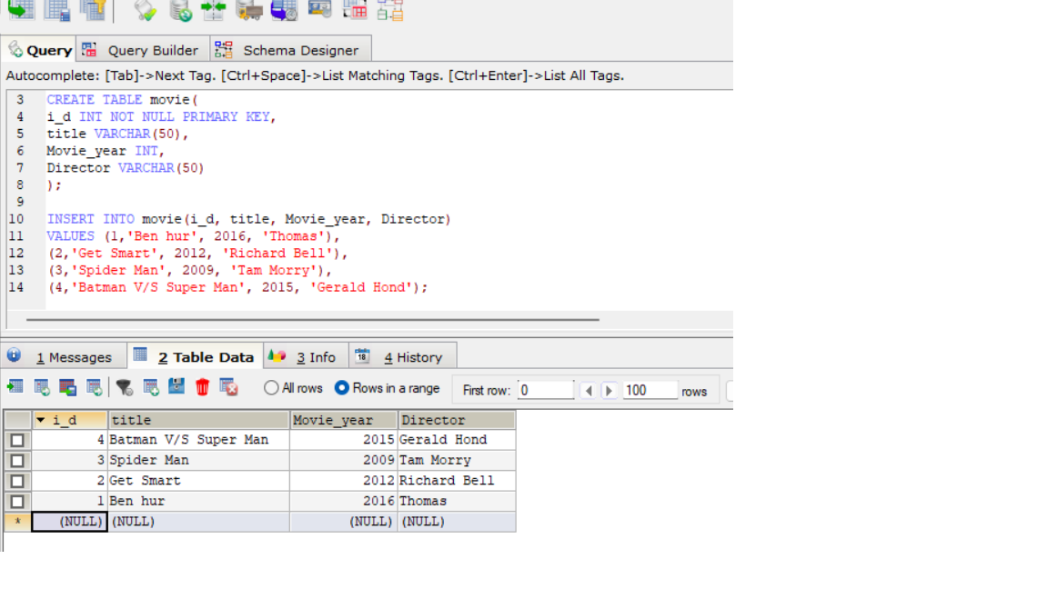

**LAB_7**

**Question 1**

Grant all privilege to user which name Ali.

**ANSWER:**

CREATE USER ‘Ali’@’localhost ‘ IDENTIFIED BY ‘123’

**Question 2**

Grant only creates permission to user which name Fahad.

**ANSWER:**

CREATE USER ‘Fahad@’localhost ‘ IDENTIFIED BY ‘1234’

GRANT INSERT ON lab5db,* TO ‘Fahad’

|  |  |  |  |
| --- | --- | --- | --- |
| **Emp_num** | **Emp_Name** | **Emp_Job** | **Emp_Sal** |
| E101 | Salman | Analyst | 6000 |
| E102 | Bushra | Programmer | 5000 |
| E103 | Madiha | Web Designer | 6000 |
| E104 | Aiman | ERD designer | 4000 |
| E105 | Hameed | Web Designer | 3000 |
| E106 | Nini | Analyst | 2500 |
| E107 | Imtiaz | Web Designer | 6500 |
| E108 | Rashid | Programmer | 4000 |
| E109 | Muzzamil | ERD designer | 2000 |

**LAB_8:**

1. List all employees’ number, employee’s name and jobs from emp.

CREATE DATABASE employee

CREATE TABLE employee(

emp_no INT NOT NULL,

emp_name VARCHAR(50),

emp_job VARCHAR(50),

emp_salary INT

);

INSERT INTO employee(emp_no, emp_name, emp_job, emp_salary)

VALUE(101, 'Salman', 'Analyst', 6000),

(101, 'Bushra', 'Programmer', 5000),

(101, 'Madiha', 'Web Designer', 6000),

(101, 'Aiman', 'ERD designer', 4000),

(101, 'Hameed', 'Web Designer', 3000),

(101, 'Nini', 'Analyst', 2500),

(101, 'Imtiaz', 'Web Designer', 6500),

(101, 'Rashid', 'Programmer', 4000),

(101, 'Muzzamil', 'ERD designer', 2000)

SELECT emp_no, emp_name, emp_job

FROM employee

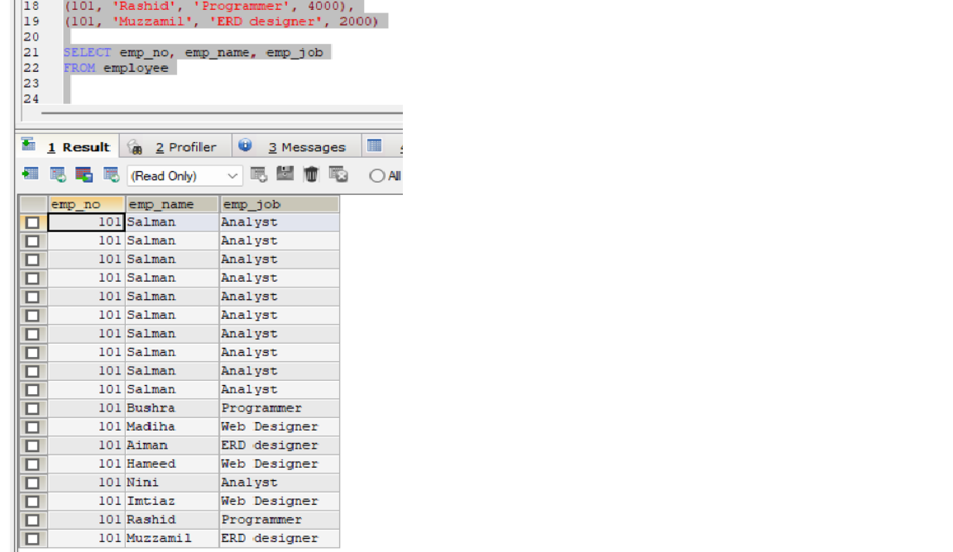

1. List all employees’ number, employee’s name and jobs from emp whose salaries greater than 5,000.

**ANSWER:**

SELECT emp_no, emp_name, emp_job, emp_salary

FROM employee

WHERE emp_salary>5000

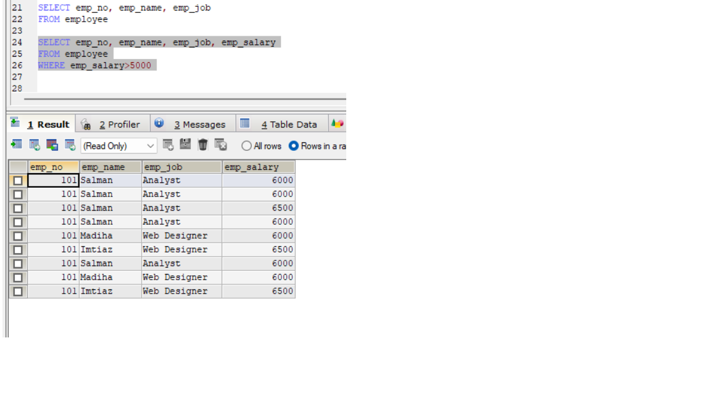

1. List all employees’ number, employee’s name and jobs from emp whose salaries less than 5,000.

**ANSWER:**

SELECT emp_no, emp_name, emp_job, emp_salary

FROM employee

WHERE emp_salary<5000

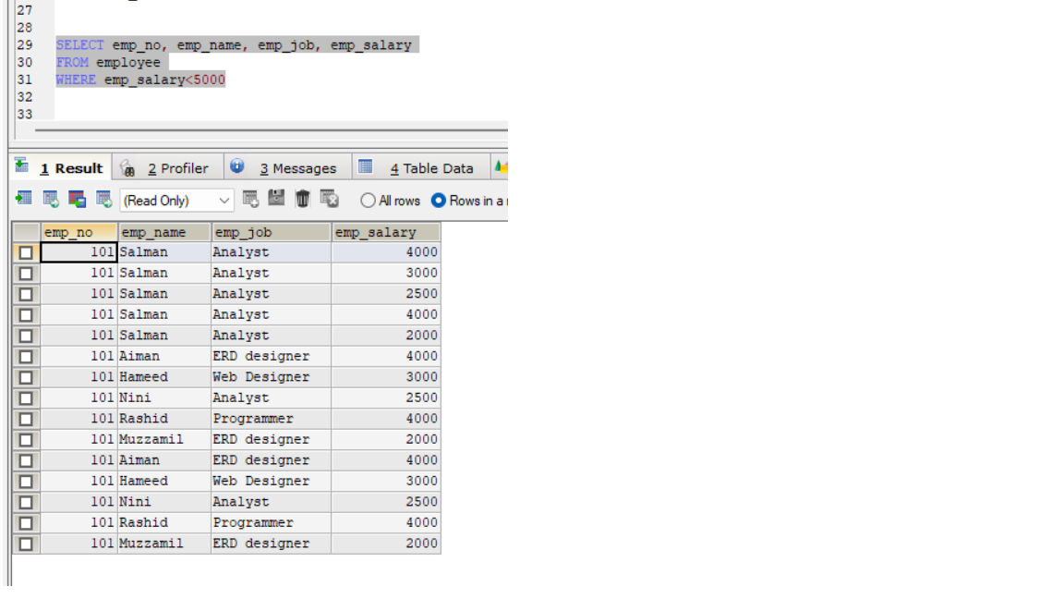

1. List all employees’ number, employee’s name and jobs from emp whose salaries between 1,000 to 5,000.

**ANSWER:**

SELECT emp_no, emp_name, emp_job, emp_salary

FROM employee

WHERE emp_salary BETWEEN 1000 AND 5000

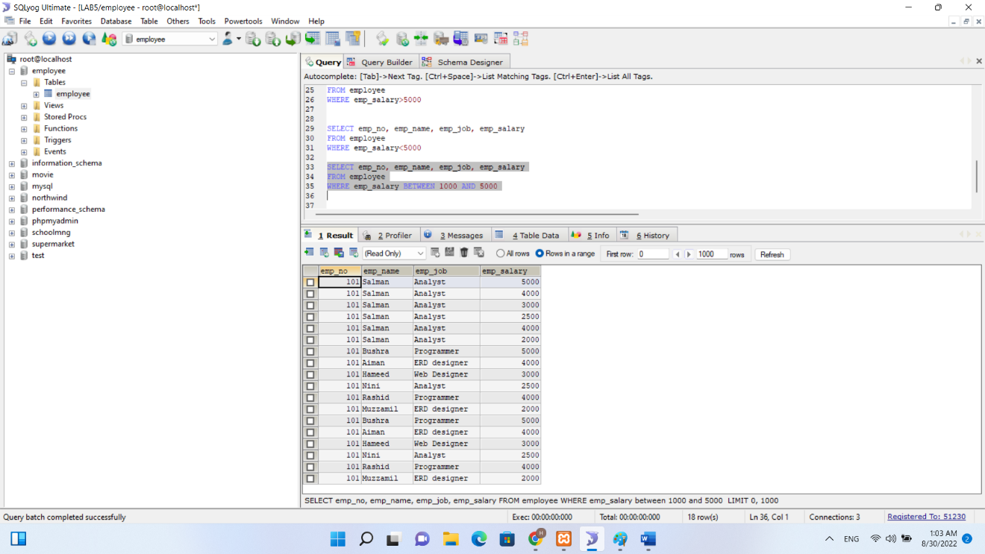

1. List all employees’ number, employee’s name, jobs and salaries from emp.

**ANSWER:**

SELECT *

FROM employee

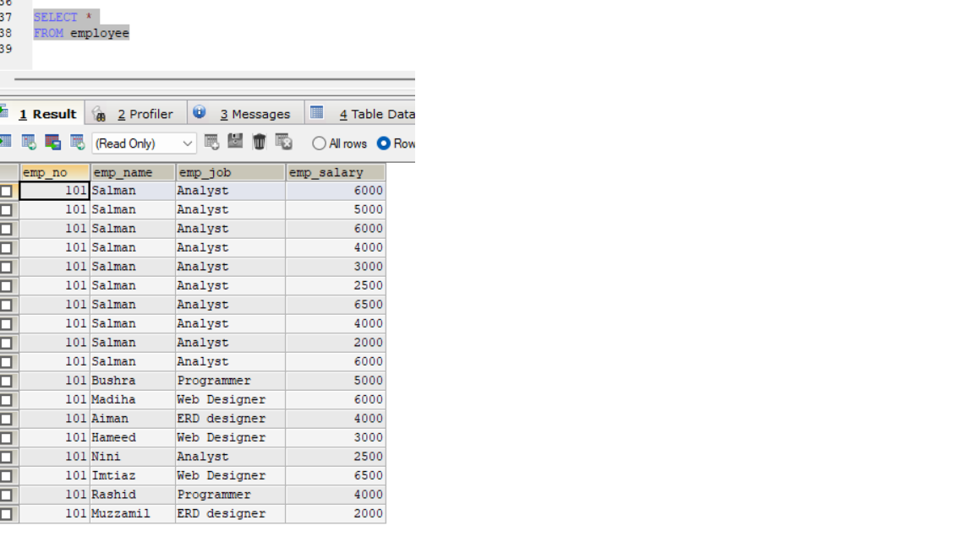

**LAB_9:**

**1. List of all supplier that palced order.**

**QUERIES:**

**SELECT s.SupplierID, o.OrderID**

**FROM suppliers AS s, orders AS o**

**OUTPUT:**

**2. List of all Product that are supplied by supplier whose id is 101.**

**QUERIES:**

**SELECT S.S_NO,S.SUP_NAME,S.SUP_ADD,S.RANK,S.SUP_ID FROM ORDERS O INNER JOIN SUPPLIER S**

**ON O.SUP_ID=S.SUP_ID**

**OUTPUT:**

**3. Find all order(s) of product named Rice.**

**QUERIES:**

**SELECT P.Prod_Name, O.ORD_ID,O.QTY**

**FROM ORDERS O LEFT JOIN PRODUCT P**

**ON O.PROD_ID=P.PROD_id WHERE P.Prod_Name='RICE'**

**OUTPUT:**

**LAB_10:**

**1. List average salary of each job.**

**QUERIES/OUTPUT:**

**select avg(salary) from customers as avgsalary;**

**2. Find average and sum of all the salaries of each job excluding clerks.**

**QUERIES/OUTPUT:**

**SELECT avg(SALARY),sum(SALARY)**

**FROM customer WHERE SALARY>all**

**( SELECT SALARY FROM customers WHERE dept ='clerk') and dept <>'clerk';**

**3. Find average and sum of the salaries of each job excluding salesmen', clerk' and 'manager'.**

**QUERIES/OUTPUT:**

**SELECT avg(SALARY),sum(SALARY)**

**FROM customers**

**WHERE SALARY>all ( SELECT SALARY FROM customers**

**WHERE dept ='clerk' and dept='manager') and dept <>'clerk';**

**4. Find count, sum and average salaries of each job excluding salesmen', clerk' and 'manager'.**

**QURIES/OUTPUT:**

**SELECT count(salary), avg(SALARY),sum(SALARY)**

**FROM customers**

**WHERE SALARY>all ( SELECT SALARY**

**FROM customers**

**WHERE dept ='clerk' and dept='manager') and dept <>'clerk';**

**5. List average salary of each department.**

**QUERIES/OUTPUT:**

**select avg(salary)**

**from customers as avgsalary**

**group by dept**

**;**

**LAB_11:**

**1. Find the names of Top 10 employees which salaries are highest.**

**QUERIES/OUTPUT:**

**Ans. SELECT * FROM customers**

**ORDER BY salary DESC LIMIT 10;**